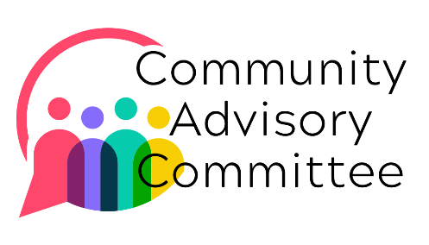
Community Advisory Committee

Charter

Introduction
This Charter establishes the Community Advisory Committee (CAC) for Ferndale Community Services (FCS), reflecting our commitment to our mission: understanding and alleviating unmet needs by providing resources and connection.

Located in Ferndale and North Whatcom County, FCS is dedicated to delivering services that reflect the real needs of our community. The CAC embodies that commitment — ensuring our programs and services align with our mission and are shaped by the voices, aspirations, and challenges of the people we serve.

Purpose and Scope
The CAC is a non-binding advisory body that provides strategic guidance, feedback, and recommendations to FCS. Its primary goal is to ensure that our programs and services effectively meet the evolving needs of the communities we serve. By creating a forum for community input, the CAC helps ensure that all initiatives are relevant, beneficial, and aligned with community interests.

Membership
The CAC will consist of 16 members representing a diversity of perspectives and experiences from North Whatcom County. This includes representation from various racial and ethnic communities, speakers of languages other than English, members of the LGBTQIA+ community, people with lived experience of poverty and system involvement, business owners, and others. Lived experience that reflects the communities FCS serves is prioritized.

Members should reside or work in North Whatcom County and bring connections or insight into the community.

Members commit to a minimum two-year term. Prospective members complete a brief application, which is reviewed on a rolling basis as openings arise. Current members review and approve new applications at least two weeks before the next scheduled meeting.

A staff member from FCS, appointed by the Executive Director (ED), will serve as CAC Liaison, supporting coordination and communication and taking notes at meetings.

General Membership Roles and Responsibilities
Responsibilities:
    - Attend all scheduled CAC meetings.
    - Participate in discussions and share insights drawn from personal experience and community connections.
    - Offer constructive feedback and recommendations that help shape the direction of FCS programs and services.
    - Serve on subcommittees and engage in special projects as needed.

Qualifications:
    - Reside or work in North Whatcom County.
    - A genuine commitment to community well-being and a desire to make a positive impact.
    - Backgrounds that may include community involvement, professional expertise, or personal experience related to the issues FCS addresses.

Meetings
The CAC will convene three times annually on a weekday evening to foster accessibility and ensure robust participation. All meetings will be conducted in person with a hybrid option available to promote direct engagement and facilitate meaningful discussions.

Each meeting will typically follow this agenda:

- Community Check in: Committee will discuss emerging needs and developments observed in the community.

- Presentations: Ferndale Community Services (FCS) staff or, occasionally, community members, will present a topic or proposal. These presentations will address current issues and developments affecting both FCS and the broader community.

- Open Discussion: Following the presentations, there will be an open forum allowing all members to discuss the topics presented, share insights, and provide feedback.

Meeting minutes will be posted on the CAC page of the FCS website and made available to all members and the public. The ED and at least one Committee Member will attend each meeting to receive input directly and ensure timely follow-through on advisory feedback.

Code of Conduct
Members are expected to engage respectfully and ensure equitable opportunities for dialogue during all CAC activities. To protect sensitive information, all members will sign a confidentiality agreement. Information identified as sensitive or confidential will not be included in meeting minutes.

Support and Resources
The CAC does not provide general compensation, but a budget is set aside for meeting-related expenses such as snacks, coffee, and printing.

Members may also request support to attend meetings, including reimbursement for gas and childcare. Requests should be directed to the ED, who will review and approve them based on need and available resources.

Review and Continuous Improvement
CAC effectiveness will be assessed through community feedback and its measurable impact on FCS's work. Every two years, the CAC will undergo a review involving the CAC, FCS leadership, and the ED to evaluate and improve its structure and processes. Each departing member will also complete an exit survey.

