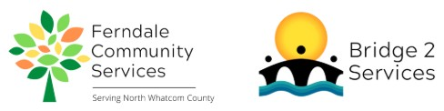
Ferndale Community Services Volunteer Position Description
Position: Bridge2Services Water Drop Volunteer
Reports to: Bridge2Services Program Manager
Summary: The Water Drop Volunteer is a summer position that helps staff our Water Brigade program. This program distributes free water at drop locations throughout Whatcom County. Volunteers commit to maintaining between 1-10 coolers: keeping them supplied with bottled water (provided by B2S), keeping the cooler and nearby area clean, and helping maintain a good relationship with our cooler host sites.
Essential Duties and Responsibilities:
- Check and maintain stock on assigned coolers.
- Keep assigned coolers clean.
- Keep area around assigned coolers clean, picking up any garbage in the immediate area.
- Check in with host businesses to see if any problems have been reported.
- Coordinate with B2S Program Manager to pick up water to distribute from the B2S warehouse.
- Communicate to the B2S Program Manager status of each cooler when checked, including info on any damaged or missing coolers and any problems reported by host businesses.
Requirements:
- Valid driver's license
- Working cell phone
- Able to lift up to 30 pounds
- Basic customer service skills and a helpful, friendly manner
- Strong written and verbal communication skills
- Must be self-directed, willing to take direction and initiative, and be detail oriented
- Must respect and maintain confidentiality of clients, donors, and other volunteers.
Training and Supervision: Water Drop Volunteers will receive in-person training on their first day of service. Follow-up training is available as needed and questions are encouraged. Volunteer is supervised by the Bridge2Services Program Manager.
Evaluation: Informal, verbal evaluation occurs after the first month of service.
Time Commitment: Approximately 1-2 hours per cooler per week, plus time to pick up water from the B2S warehouse.
Benefits:
- Gain work experience and receive reference upon request
- Serve your community
Mission:
Ferndale Community Servies is a 501c3 non-profit organization that serves the greater Ferndale and North Whatcom County community. Our mission is to identify and alleviate unmet needs by providing support and connection to build a thriving community. We envision a community where all people’s basic needs are met, and they are supported and valued.

