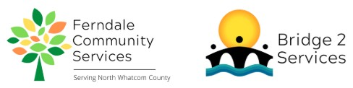
Ferndale Community Services Volunteer Position Description
Position: Bridge2Services Supply Bundler Volunteer
Reports to: Bridge2Services Program Manager
Summary: The Supply Bundler Volunteer helps package goods for distribution through our Mobile Resource Center. They are given a checklist of supplies, which are provided by B2S, to create bundles that are given to unhoused individuals and families. Volunteers are able to either work on site at our administrative building or pick up the supplies and bundle them at home.
Essential Duties and Responsibilities:
- Package goods for distribution following a provided checklist, ensuring that all required supplies are included in each bundle.
- Ensure that goods are packaged in such a way that they will not be damaged when transported.
- Coordinate with B2S Program Manager to schedule bundling shifts, or for volunteers who wish to work from home, scheduling pick up times for bundling supplies.
- Communicate to the B2S Program Manager any issues with supply availability or quality.
Requirements:
- Reliable means of transportation
- Reliable means of communication
- Able to lift up to 30 pounds
- Strong written and verbal communication skills
- Must be self-directed, willing to take direction and initiative, and be detail oriented
- Must respect and maintain confidentiality of clients, donors, and other volunteers.
Training and Supervision: Supply Bundler Volunteers will receive in-person training on their first day of service. Follow-up training is available as needed and questions are encouraged. Volunteer is supervised by the Bridge2Services Program Manager.
Evaluation: Informal, verbal evaluation occurs after the first month of service.
Time Commitment: Approximately 4-5 hours per week
Benefits:
- Gain work experience and receive reference upon request
- Serve your community
Mission:
Ferndale Community Servies is a 501c3 non-profit organization that serves the greater Ferndale and North Whatcom County community. Our mission is to identify and alleviate unmet needs by providing support and connection to build a thriving community. We envision a community where all people’s basic needs are met, and they are supported and valued.

