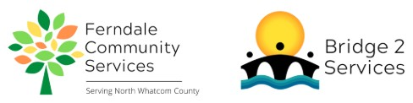
Ferndale Community Services Volunteer Position Description
Position: Bridge2Services Donation Transport Volunteer
Reports to: Bridge2Services Program Manager
Summary: The Donation Transport Volunteer picks up donations from drop locations around Whatcom County. Volunteers commit to maintain between 1-5 donation drop locations: picking up and transporting donations to our B2S warehouse, scheduling pickups and drop offs, keeping the donation drop box and nearby area clean, and helping maintain a good relationship with donation drop host sites.
Essential Duties and Responsibilities:
- Regularly check assigned drop box locations for any donations.
- Keep drop boxes and the nearby area clean, picking up any garbage in the immediate area.
- Check in with host businesses to see if any problems have been reported.
- Coordinate with B2S Program Manager to schedule donation drop off times at the B2S warehouse.
- Communicate to the B2S Program Manager the status of each drop box when checked, including info on any damaged or missing boxes and any problems reported by host businesses.
Requirements:
- Valid driver's license
- Working cell phone
- Able to lift up to 30 pounds
- Basic customer service skills and a helpful, friendly manner
- Strong written and verbal communication skills
- Must be self-directed, willing to take direction and initiative, and be detail oriented
- Must respect and maintain confidentiality of clients, donors, and other volunteers.
Training and Supervision: Donation Transport Volunteers will receive in-person training on their first day of service. Follow-up training is available as needed and questions are encouraged. Volunteer is supervised by the Bridge2Services Program Manager.
Evaluation: Informal, verbal evaluation occurs after the first month of service.
Time Commitment: Approximately 1-2 hours per box per week, plus time to drop off donations at the B2S warehouse.
Benefits:
- Gain work experience and receive reference upon request
- Serve your community
Mission:
Ferndale Community Servies is a 501c3 non-profit organization that serves the greater Ferndale and North Whatcom County community. Our mission is to identify and alleviate unmet needs by providing support and connection to build a thriving community. We envision a community where all people’s basic needs are met, and they are supported and valued.

