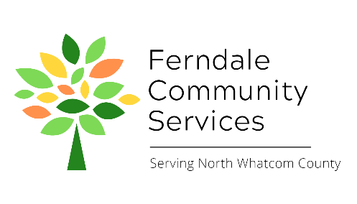
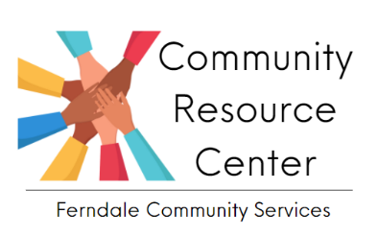

Ferndale Community Services Volunteer Position Description
Position: Resource Center Front Desk Volunteer
Reports to: Resource Center Program Manager
Summary: The Front Desk Volunteer greets and supports guests of the Resource Center and serves as a point of contact for information about our programs, community programs, and other resources. They distribute direct services to guests, keep the Resource Center tidy and organized, answer phones and voicemail, assist guests with tasks on the computer and phone, and more.
Essential Duties and Responsibilities:
- Greet guests and meet needs, talking with guests and maintaining confidentiality as much as possible. Answer questions about programs and services and pass messages when necessary.
- Assist guests with clothing bank items as needed.
- Distribute direct services upon request, including hygiene items, food, bus passes, shower passes, following all procedures for proper documentation and tracking.
- Answer phones and return voicemails.
- Assist guests with computer, printer, and fax access as needed.
- Help guests find community resources via online search, with or for them. Help with phone access as needed.
- Accept donations and follow all procedures for tracking and storing.
- Keep Resource Center tidy and organized.
Requirements:
- Professional appearance and helpful, friendly manner
- Must be punctual and dependable
- Basic customer service skills and ability to serve in a busy environment
- Basic computer skills preferred- ability to assist with things like word processing, internet search, printing, etc.
- Strong written and verbal communication skills, second language skills a plus but not required
- Must be self-directed, willing to take direction and initiative, and be detail oriented
- Must respect and maintain confidentiality of guests, donors, and other volunteers
Training and Supervision: Front Desk Volunteers receive the Volunteer Manual which outlines all policies and procedures for the position, and also receive in person training on their first day of service. Follow up training is available as needed and questions are encouraged. Volunteer is supervised by the Executive Director.
Evaluation: Informal, verbal evaluation occurs after the first month of service. Check-ins with the Executive Director on performance, strengths and challenges occur annually.
Time Commitment: This position is a weekly (or bi-weekly) 4 hour shift of service in-person at the Resource Center for a minimum of 6 months.
Benefits:
- Gain work experience and receive reference upon request
- Serve your community
- Free refreshments!
Mission
Ferndale Community Services is a 501c3 non-profit organization that serves the greater Ferndale and North Whatcom County community. Our mission is to identify and alleviate unmet needs by providing support and connection to build a thriving community. We envision a community where all people’s basic needs are met, and they are supported and valued.

