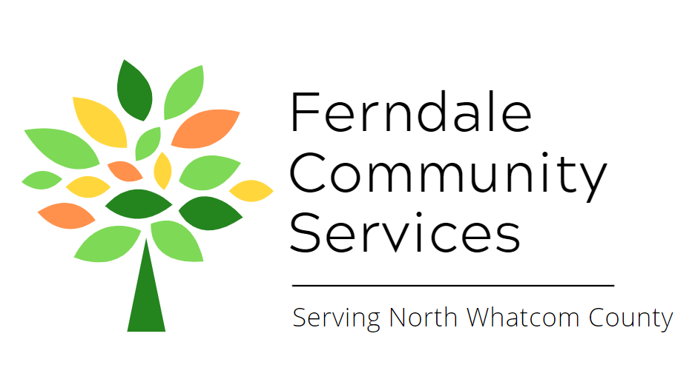
Board Member Job Description
Ferndale Community Services
Member of the Board of Directors

Mission
The Ferndale Community Services is a nonprofit organization that identifies and alleviates unmet needs by providing support and connection to build a thriving community.
For more information about Ferndale Community Services and its programs visit www.ferndalecs.org

Position
The Board is an integral part of the proper functioning of Ferndale Community Services’ programs. Board members support the work of FCS and provide mission-based leadership. While day-to-day operations are led by the Executive Director, Board members work as trusted partners on a variety of projects and initiatives. Active involvement of all Board members is both critical and expected. Specific Board Member responsibilities include:
Leadership, governance, and oversight
- Serving as a trusted advisor to the Executive Director and Program Coordinators as s/he develops and implements the program’s work
- In partnership with Executive Director, developing outcomes and metrics for each program and then reviewing those outcomes and metrics to evaluate impacts and to determine program performance and effectiveness
- Reviewing agenda and supporting materials prior to board and committee meetings
- Approving FCS’s annual budget, audit reports, and material business decisions; being informed of, and meeting all legal and fiduciary responsibilities
- Contributing to performance evaluations of the Executive Director
- Assisting the Board Chair in identifying and recruiting other Board Members
- Partnering with the Executive Director and other board members to ensure that board resolutions are carried out
- Serving on committees or task forces and taking on special assignments
- Representing FCS to stakeholders and acting as an ambassador for FCS and its programs
- Ensuring FCS’s commitment to a diverse board and staff that reflects the Ferndale community

Fundraising and Resources
Board members are expected to make a significant personal contribution to FCS. This can be a financial donation, and all board members are encouraged to attend and support the organization at its annual fundraisers. This commitment can also include board member time and talents, particularly in regards to fundraising, including but not limited to collaborating with the Executive Director on grant opportunities, leveraging personal networks to find support, and creating connections to potential funders. Significant personal contribution can also include volunteering in one of FCS’s programs as well.
Board terms/participation
FCSC Board Members will serve a two-year term to be eligible for re-appointment for two additional term. Board meetings will be held monthly and committee meetings will be held ad-hoc and in coordination with full board meetings.
Qualifications
This is a great opportunity for community minded individuals who are passionate about FCS’s mission and programs and who have a desire to serve their community. Previous board experience is preferred, but not necessary. Experience and leadership accomplishments in business, government, philanthropy, or the nonprofit sector are also preferred but not required. FCS also greatly values community involvement and representation, so all interested community members who want to enhance Ferndale should apply. Other skill qualifications include:
- A commitment to understanding FCS’s programs and service model
- A commitment to understanding the needs of the community
- Strong communication skills and a natural ability to cultivate relationships
- Strong commitment to making Ferndale a welcoming, inclusive, and safe community for everyone
- Personal qualities of integrity, credibility, and a passion for improving the lives of Ferndale residents and FCS’s beneficiaries
Service on the FCS board is voluntary and unpaid, except for pre-approved administrative support, travel, and accommodation costs in relation to Board Members’ duties.

Adapted from Bridgestar, a Bridgespan initative. (www.bridgestar.org)

